Spring AOP (Aspect-Oriented Programming) – Easy Theory with Diagram

What is AOP in Spring?
AOP stands for Aspect-Oriented Programming.
Spring AOP is used to handle common tasks such as logging, security, transaction management, and exception handling separately from the main business logic.
Let's understand it with a simple real-time example of a bank.

Real-Time Example: Bank Application
Imagine a bank application where a customer performs three operations:
- Check account balance
- Deposit money
- Withdraw money
Whenever a customer performs any operation, the bank may need to perform some additional tasks:
- Check whether the customer is authorized.
- Record the activity in a log.
- Check the transaction details.
- Handle any errors.
These additional tasks are required in multiple operations. Instead of writing the same code in every method, Spring AOP allows us to manage these tasks separately.

Diagram 1: Without AOP
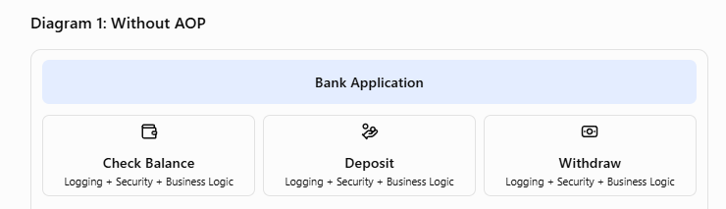The same additional code must be repeated in multiple methods.
Problem: If we need to change the logging or security code, we may need to update several methods. This makes the application harder to maintain.

Diagram 2: With Spring AOP
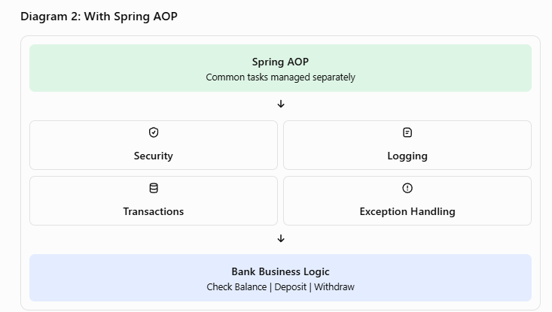Benefit: We write the common task logic separately and configure where it should run. Spring AOP applies the relevant advice when the configured methods execute.

Real-time example: ATM withdrawal
Imagine a customer withdraws ₹5,000 from an ATM.

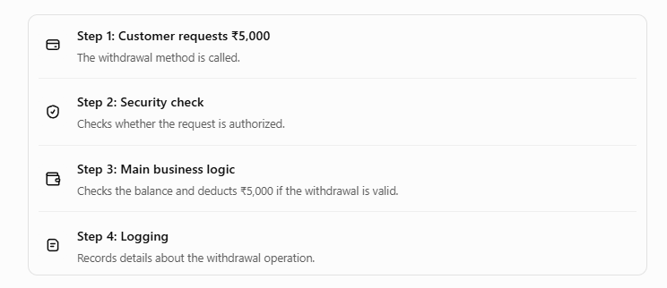
The withdrawal code focuses on withdrawing money. Common tasks, such as logging, can be handled separately through AOP. Security checks and transaction management still need appropriate configuration; AOP does not automatically make every operation secure.

Important AOP terms
Term | Easy meaning | Bank example
Aspect | Class or module containing common task logic | Logging aspect
Advice | What action should execute | Print a transaction log
Join Point | A point during program execution where advice may apply | Execution of withdraw()
Pointcut | Rule that selects which methods are targeted | All methods in the bank service
Weaving | Connecting aspects with the target execution | Applying logging to withdrawal
Target Object | The object containing the main business logic | BankService
Proxy | Object through which Spring commonly intercepts calls | Spring-managed proxy for BankService

Types of Advice in Spring AOP
Advice | When does it execute? | Example
@Before | Before the method executes | Log withdrawal request
@After | After the method finishes, whether normally or exceptionally | Record that the method finished
@AfterReturning | After successful completion | Log successful deposit
@AfterThrowing | If the method throws an exception | Log withdrawal failure
@Around | Before and after the method, with control over proceeding | Measure execution time

Simple code example
The following example shows how logging can be separated from bank business logic.
BankService.java
import org.springframework.stereotype.Service;

@Service
public class BankService {

public void withdraw() {
System.out.println("Withdrawing money...");
}
}
BankLoggingAspect.java
import org.aspectj.lang.annotation.Aspect;
import org.aspectj.lang.annotation.Before;
import org.springframework.stereotype.Component;

@Aspect
@Component
public class BankLoggingAspect {

@Before("execution(* BankService.withdraw(..))")
public void logBeforeWithdraw() {
System.out.println("Withdrawal operation started");
}
}
When withdraw() is called through the Spring-managed bean, the output will be:
Withdrawal operation started
Withdrawing money...
The @Before advice executes before the withdrawal method. The aspect contains the logging logic, while BankService contains the main business logic.
Note: This is a simplified illustration. A real project must also configure Spring AOP correctly, and the pointcut expression may need the fully qualified package name.

Where do we use Spring AOP?
- Banking: Logging deposits and withdrawals.
- E-commerce: Logging order processing.
- Security: Applying authorization checks.
- Database applications: Supporting transaction management.
- Enterprise applications: Measuring method execution time and recording errors.
Remember this simple definition for students:
Spring AOP allows us to separate common tasks such as logging, security, and transaction management from the main business logic, so we can reuse and maintain that code more easily.

